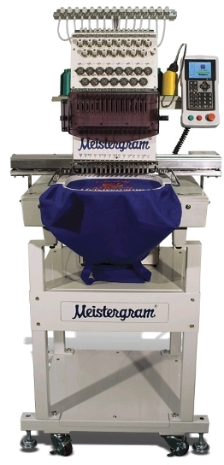
Instruction Manual

Features  - LCD Monitor  - Load Design USB & USB Disk Drive  - Design Rotation/Scaling  - Thread Break Detect  - Work Sequence  - Frame protection  - Auto Origin Return  - Idle (Float) Mode  - Design Operation  - Frame Position / Restore  - Cyclic Embroidery  - Trimming  Control and Basic Operations  - Control Panel  - Main Screen Keys and Functions  - Definition and Basic Key Operations  - Indicator Light of Main Shaft Stop Position  Basic Knowledge and Operations  - Work status, Embroidery Mode and Work Sequence  - Design Input (USB and USB Floppy Disk)  - Select Design for Embroidery  Setting Parameters  - Parameter Menu  - Real Time Rotation/Scaling  - Setting Repetition  - Offset Point  - Cyclic Embroidery  - Work Sequence  - Standard Embroidery  - Standard Trim  - Standard Machine  - Common  Manual Operation  - Origin back/Stop back  - Main Shaft Origin  - Frame Range  - Embroidery Range  - Embroider a Line  Disk Management  - List Floppy and USB Directory  - Disk Design  - Delete USB or Floppy Designs  - Format Disk  Memory Design Operation  - Enter Memory Design Operations  - Design for Embroidery  - Delete Memory Design  - Copy Design  - Divide a Design  - Clear All  - Rename a File  Assistant Function  - Set Soft Limit  - Frame Restore  - Default Setup  - Switch Language  - Set Frame Origin  - Machine Self Test  - Test Machine Parts  - Set Password  - Set Network Address  Appendix | Page (s)  1-4  5-12  13-22  23-40  41-46  47-50  51-58  59-63  64-71

Machine Features

CAUTION: Machine should be grounded to work properly and avoid possible damage to your machine.

- LCD Monitor
This model machine is equipped with an LCD monitor: which displays descriptions and icons for fast learning and easy operation. In load USB design and memory, the design will be displayed in the left hand corner. During embroidery, design and design progress will appear in the center of your control panel.

- Design Load from USB and USB Floppy
Locate the “Appendix” in the back of this manual for the supported extensions. (p.70)

- Storage Capacity
The built-in storage can hold up to 99 designs and the stored maximum stitches are 1,000,000.

- Speed Control
Press the speed control keys to adjust the current speed of the main shaft between 450rpm and 1000rpm. This current speed will show on the screen.

- Scaling Up/Down and Rotation (Real Time)
While embroidering a design from memory, the user can scale the design Up/Down from 50% to 200% separately in either vertical or horizontal directions.
  - Note: Whether you size up or down, the number of stitches in the design remains the same. It is recommended that you use your software and the original editing file for scaling.

- Detecting Thread Breaks
In parameter settings, the user has the option to select thread break detect or no thread break detect. When thread break detect is active, the machine will stop automatically and show an icon on the screen when there is a thread break.

- Work Sequence
The “work sequence” is the order in which you want your color changes.

- Over-Frame Protection
Setting this parameter prevents the frame from exceeding the normal range causing an accidental collision.

- Auto Origin Return
The frame will return to the origin point (beginning) once the embroidery is complete.

- Position Idling
With this feature, you can move forward or backward to anywhere in the design without embroidery. Use “position idling” to take you back to a point in the design that might need a touch-up or did not finish.

- Repetition Embroidery Function
Maximum repetition per one design is 99 times in each vertical and horizontal direction.

- Design Operation
The user can view the memory directory, delete, copy, combine or divide the design.

- Disk Management
List the design files, load/export files and format the Disk/USB.

- Error Information
In case of incorrect operation or machine malfunction, the screen will display the description of error or icons to inform you.

- Frame Protection
When the frame’s position has been moved after power-off during embroidery or after the machine has been stopped, the machine will not be able to continue the current design without starting it over. To prevent this from happening, activate “frame protection” parameter. Once this is active, the user can restore the frame position and continue the embroidery with “Frame Restore” Parameter.

- Adjustment of the “Stop Position” (Parameter “Set Break Para”)
Some machine settings will require different “Stop Position” settings. This parameter is available to change and the higher the value, the larger the additional degrees the main shaft will stop with.

- Returning and Patching
In case of thread breaks, the user can automatically return in number of stitches back or manually hit the stop button until needle is positioned over the point of return.

- Combining Designs
A new design can be created by combining several other designs with different parameter settings. The combined designs can be embroidered together.

- Cyclic Embroidery
This function tells the machine to automatically return to the point of origin to start again after embroidery of the first design.

- Offset Point
This is to set an “offset point” anywhere away from the start point.

- Trimming
During embroidery, the user can choose automatic trimming or manual trim.
Main Screen

Following power-on, the machine will start up and display the main screen. In the main screen, there are nine (9) icons. For definitions of these icons, see below.

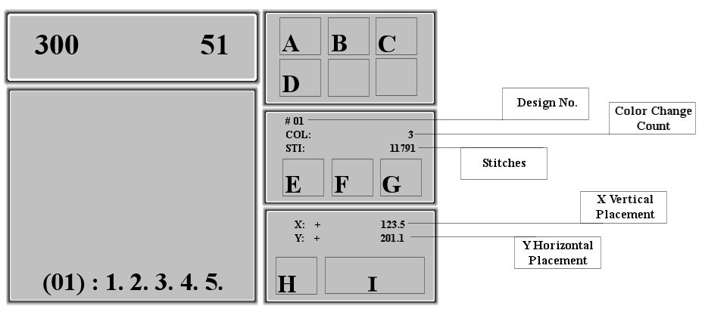

Icon Definitions:

There are TWO icons that will display in box A of the Control Panel.
(Refer to the Graph Above.)
The icon 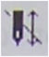 means you’re currently in preparation status and 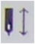 means embroidery confirmation status.

- Preparation status allows you to select design, change the parameters, direction in which the embroidery will begin to sew; size, color options, trace and so forth.
- Once you are in “Embroidery Confirmation” status, the system will not allow you to make other changes.
- To switch between preparation and confirmation, press the confirmation key 

Displays the color change and start mode. 
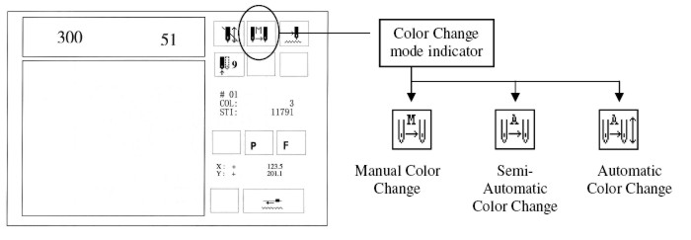
- 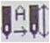Auto Color Change/Auto Start: In this mode, the machine will change and start the next color automatically.
- 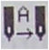Auto Color Change/Manual Start: This mode will change the color automatically and the operator manually starts the design each time.
- 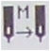Manual Color Change/ Manual Start: In this mode, the operator will manually change the colors and manually start the machine again.

Embroidery Status
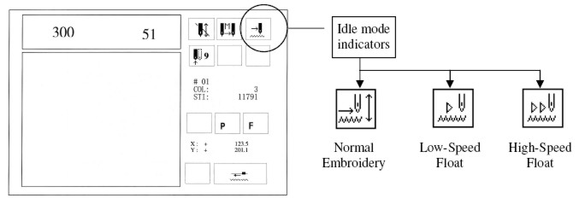
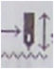 Normal – Embroidery
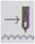 Low - speed idling forward or backward in “low-speed” to any location in the design.
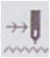 High - speed idling forward or backward in “high-speed” to any location in the design.

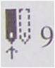 Current Needle Position
Example: To change needle one (1) to needle nine (9) use your numeric key pad to select the needle. For 10-15, use the 10+1 for 11 and so forth.

Cyclic Embroidery

(P) Orientation
- The icon will show the rotation parameters.
- Stand scales X: 100% Y: 100% - Design direction P – Rotation Angle: 0
- Change the rotation or scale up/down.

Embroidery Repetition
- shows no repetition (X and Y are both set at 1)
- Normal repetition (X and Y are set 2-99)
Special Operations or Causes for the Machine Stopping during Embroidery.
- “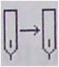” Appears at each color change code in the Embroidery.
- “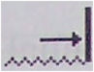” Embroidery comes to an End.
- “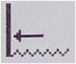” Machine returns to start point.
- “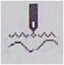” Machine stops and thread break has been detected.
- “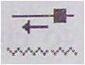” Machine stops because the STOP button is pressed.
- “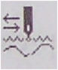” Machine stops after it returns for patching and embroiders to the thread break point.

Also on your Main Screen (Refer to Page 5) to view Control Panel
- Design Number: displays the number of your design in memory.
- Stitches: displays the number of stitches in your design
- Speed Controls: for speeding the machine up or slowing it down.
- Stitch Count: counts the stitches since the last clearance. To clear the stitch count odometer, follow the instructions below.
Clear the Count: Press the [CL] key on the control panel and  to confirm. Then select “Clear Add Stitch” to reset the count. Otherwise, press the  key to exit the operation.
- Frame Coordinate: X and Y coordinates of the design are located on the right of the control panel. (pg. 5 Example: “X:+ 123.5 Y-201.1”)
To clear the coordinates, press [CL] on the panel, select the second option “Clr Frame Coordinate” and confirm this action by pressing. The coordinate’s value will go back to Zero value, to exit.

Definition and Basic Operation of Keys

Disk Operation
This machine comes with the USB & USB Floppy. The disk operation is for all operations concerning the disk or USB, including listing designs in floppy/USB disk, loading floppy disk/USB designs into memory, deleting disk designs, transferring design data from memory to floppy/USB and formatting.

 Design Operation
All operations concerning the design (files/data), including selecting the design, memory stored design display, loading design from floppy disk/USB, editing batch design, clearing all designs, deleting/copying/combining/dividing memory stored design, renaming design file, expanding satin and create letter design. Please refer to Part VII Memory Design Operation.

 Parameter Operation
There are two pages for parameter settings. One is for design parameter operations, including scaling up/down, design direction, rotation angle, repetition priority, repetition times, repetition interval, offset origin, cyclic embroidery and work sequence. The other page is for standard data, trim and machine parameters, and common parameters. The user can select the parameters to enter the next level of menus for setting. Please refer to Part IV.

 Manual Operation
This key is for all manual operations: such as, showing frame operations and positioning floating, etcetera. Please refer to Part V for details.

Switch Key for Working Methods
Press this key to switch between “manual color change and startup” without application of work sequence and embroidering in the set work sequence. When the machine embroiders in the set work sequence, the sequence is highlighted and displayed with this icon in the main menu or it is not set in work sequence.

 Assistant Function
Default setup, language choice, etcetera. Please refer to Part VIII.

 Embroidery Method
Use this key to switch from normal embroidery, high-speed floating (idling) and low-speed floating (idling). Floating takes you to an area in the design that needs to be sewn again. High and low speed floating allows you to move anywhere in the design.

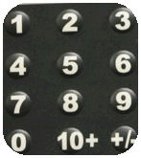
Numerical keys
Keys “+/-, 0, 1-9” are used for loading a design by number, design name and various data parameters.

 This key is used for loading special operations such as design name data.

[CL] Clearing
This key is used for clearing errors, information or data such as stitch count and frame coordinates.

Exit Key
Before confirmation in all operations, press the ESC key to end the operation and return to the upper menu. Keep pressing the key to return to the main menu.

Confirmation Key (ENTER)
This key is used to confirm all operations and data.

Manual frame-moving key
 Switch between two frame moving speeds.
- High →→
- Low →
In the main menu, press one of the directional keys to move the frame where embroidery is to be placed before embroidery starts. The directional keys are Left, Right, Up and Down or press two neighboring keys at the same time to move the frame in the direction of the angle bisector.

In all function and menu operations, pressto move the cursor in the horizontal direction or to turn a page while pressing Up/Down arrows to move the cursor in the vertical direction.

Direct Control Key
 Use this key to decrease the embroidery rotating speed. In the main menu, for each time you press this key it will slow down 10rpm. Keep pressing it and the rotation speed will decrease until 150rpm.
 Use this key to increase the embroidery rotation speed by 10rpm for each time the key is pressed. The speed will increase up to the highest speed of 1000rpm. The standard embroidery speed is 650 to 1000rpm.

NOTE: Only and can be used during embroidery.

Indicator Light of Main Shaft Stop Position
When the “Main Shaft” is not positioned at 100 degrees the light goes off. To re-position the Shaft, press  key or turn the knob on right side of machine to manually turn to 100 degrees. The main shaft has to be at 100 degrees before embroidering, returning, moving frame, etc.

The Start and Stop Button
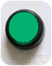 | The start button (Green) is on the operation box and it is for starting the embroidery. Use the start button to continue embroidery when the machine has stopped.
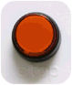 | The stop button (Red) is on the operation box and it is for stopping the embroidery.
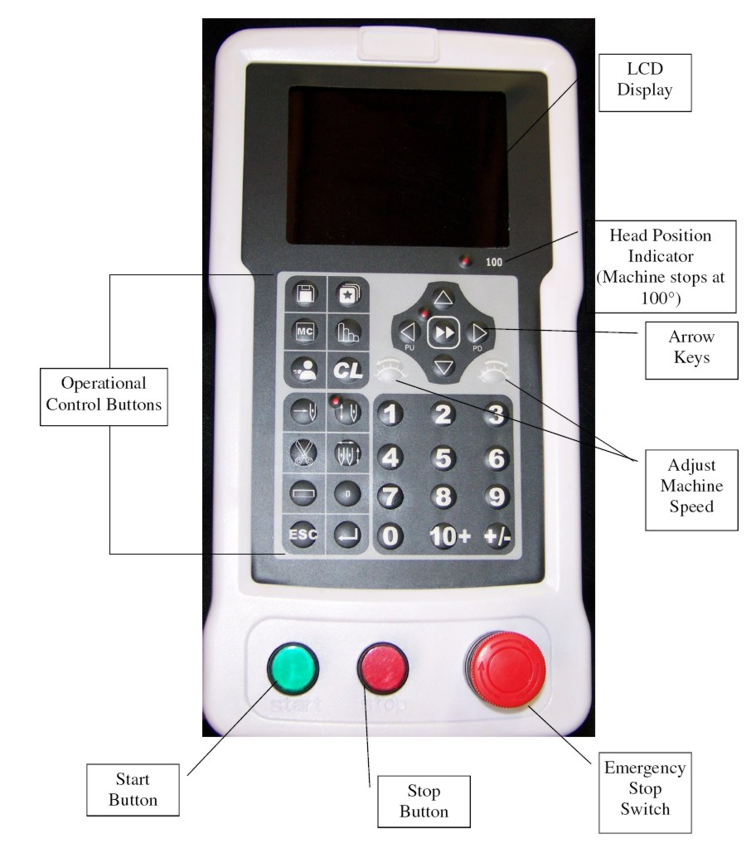

Work Status, Embroidery Mode and Work Sequence

- Work Status
The machine has two status functions: Embroidery preparation and embroidery confirmation. The icon means the system is in embroidery preparation mode and the icon means the system is currently in embroidery confirmation status.

Under status, the user can prepare for embroidery; after entering the status, the user can begin the embroidery. In status, it is no longer permitted to change the parameters which will affect the design embroidery.

Under status, press the key to enter the embroidery confirm status; under status, press the key and key to switch from the confirmation to preparation status.

When a design is loaded into the memory under status, the machine will automatically enter the embroidery confirmation status and then embroidery will start when the start button is pressed.

- Embroidery Method and Returning
The machine has the following embroidery methods: Normal embroidery, low-speed idling and high-speed idling.
Icon for Normal Embroidery – the method used to embroider design.
Icon for Low-Speed Idling – Assistant embroidery method used to float to a part in the design in low-speed for patching.
Icon for High-Speed Idling - Assistant embroidery method used to float to a part in the design in high-speed for patching.
Press this key to switch among the three methods.
Under embroidery confirmation status and in normal embroidery mode, press the start key and then the main shaft rotates and moves according to the design data. The stitches are counted and embroidered on the fabric to form the design.

If the frame return is permitted in parameter setting, press the stop button. When the machine stops, trace back through the design by pressing STOP key. Keep pressing and the frame will return stitch by stitch and 10 single-stitch returns will enable the continuous return. The return will continue even when the stop button is released. Press the stop button once more to stop the return. When the return operation stops, the user can then press the startup button to start patching.

Machine set on Low-Speed Floating: If the machine is set as low-speed floating when the user presses the start button, the frame will move forward along the stitch trace with the main shaft rotating; when the user presses the stop button, the frame will move backward along the stitch trace with the main shaft not rotating.
Machine set on High-Speed Floating: If the machine is set on high-speed floating when the user presses the start button, the main shaft will remain still and the stitch count is added; when the stop button is pressed, the machine will move directly to the position corresponding to the current stitch count. When the user presses the stop button, the frame and the main shaft will remain still and the stitch count is reduced; when the stop button is pressed, the frame will move directly to the position corresponding to the current stitch count.

- Work Sequence
This is the order of color changes for your design. The user can change the work sequence in the operation parameters or change to manually load “” each color before each color change. Work sequence is located in the left box, bottom/center corner of your control panel. The (01) represents the current color change and the 1.2.3.4.5 represents the color change sequence.
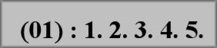

Load Design from USB and Starting First Embroidery
- Load design from disk
Machine embroidery is based on the design data in its memory, so it is necessary to load design from USB/disk to the machine memory before embroidery. Loading a design can be done two ways: by USB operation or Design operation.

Design Operation:
- Insert the USB - Press the key to enter the memory design operation menu.
The following screen will appear.
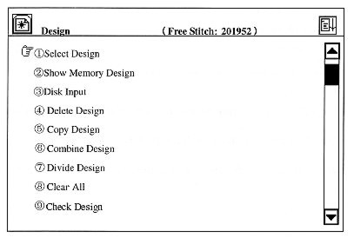
- Using your key pad or up/down arrows to move the cursor to the third option “disk input”, and then press the enter key .
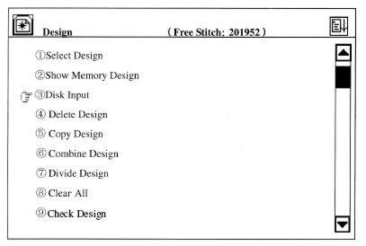

- The driver begins to read the disk directory and then is displayed on the screen. The user can press to flip through pages, the using the up/down arrows to move the cursor to select the design and press to confirm the selection.

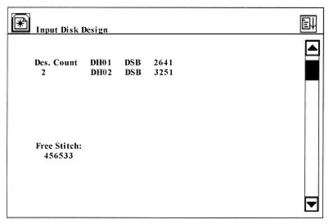
- The machine automatically provides and displays the smallest number available for the new memory design. It is possible to load other numbers since there is a cursor here. For instance, the smallest number is 20 and the user wants to input a new number of 65. The user will then press the keys “6” and “5” on the keypad and then to confirm. If the number has been used by another design, the confirmation will not be accepted. Otherwise, the following operations can be done. If the user wants to change the design number, press the [CL] key.
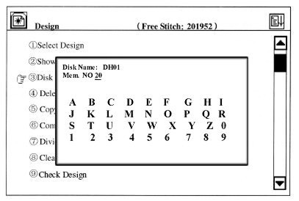

- In the screen above, you are asked to enter the design information. If it is the same to its disk name, press to confirm; otherwise, move the cursor to the selected letter by using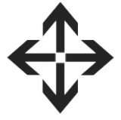, press to input the letter and to confirm the name. The user can press [CL] for re-inputting the name.
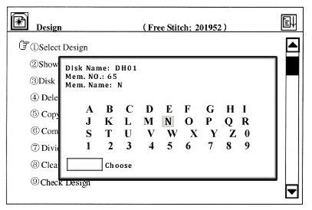
- The system begins the design input, during which the screen shows its progress bar. While in the preparation status, the system will automatically enter the operation of parameter. If in embroidery status, the system will ask whether to embroider the design using the current changes.

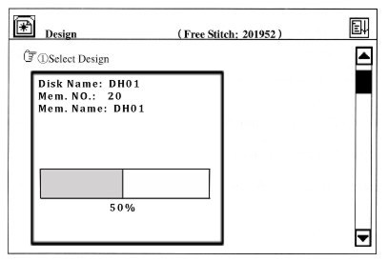

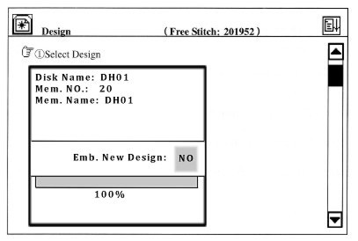
If the user chooses “No”, the system will return to the main menu after the operator presses the confirmation key. If the user chooses “Yes” by using the, the system will enter the parameter menu for the parameter settings.
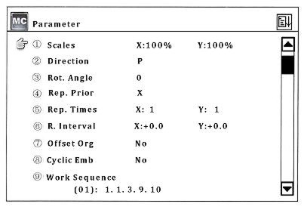
- If you do not want to change the setup, press ESC to return to the main screen and the system will automatically enter the embroidery confirmation status with an icon. (If you want to change the parameter values, please refer to Part IV)

Preparation before Embroidery
- To set the frame at the beginning position.
- Check bobbin and hoop your material.
- Make sure you are in normal embroidery mode
- Ensure that the main shaft has stopped at 100 degree. The LCD light will be on. If not, move the main shaft to the position manually or press to reset the shaft.

Select Memory Design for Embroidery
Before embroidering, you must first select a design and confirm.
- In the main screen, make sure you are in “Preparation Mode”. If not, press and return to preparation mode. (Light Off)
- Press to enter the design operation menu.
- Press and the following prompt will appear.
- If you know the number for the design in memory intended for embroidery, you can input the number by pressing the numeric keys on your control panel and then to confirm. Example: Press keys 1 and 5 for 15 and. If design number 15 exists, it will be set for embroidery and the screen will switch to the parameter operation menu (refer to Part IV). If No. 15 does not exist, the confirmation will not be accepted. Then you will need to press the [CL] to clear the input and re-enter a new number.

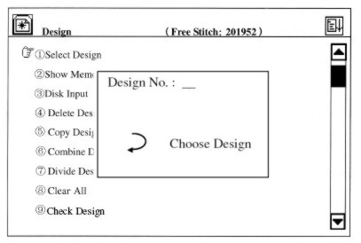

If you press according to the prompt in the above menu (you did not input the design number or pressed [CL] to clear the number) the design directory of the memory will be displayed in the screen.
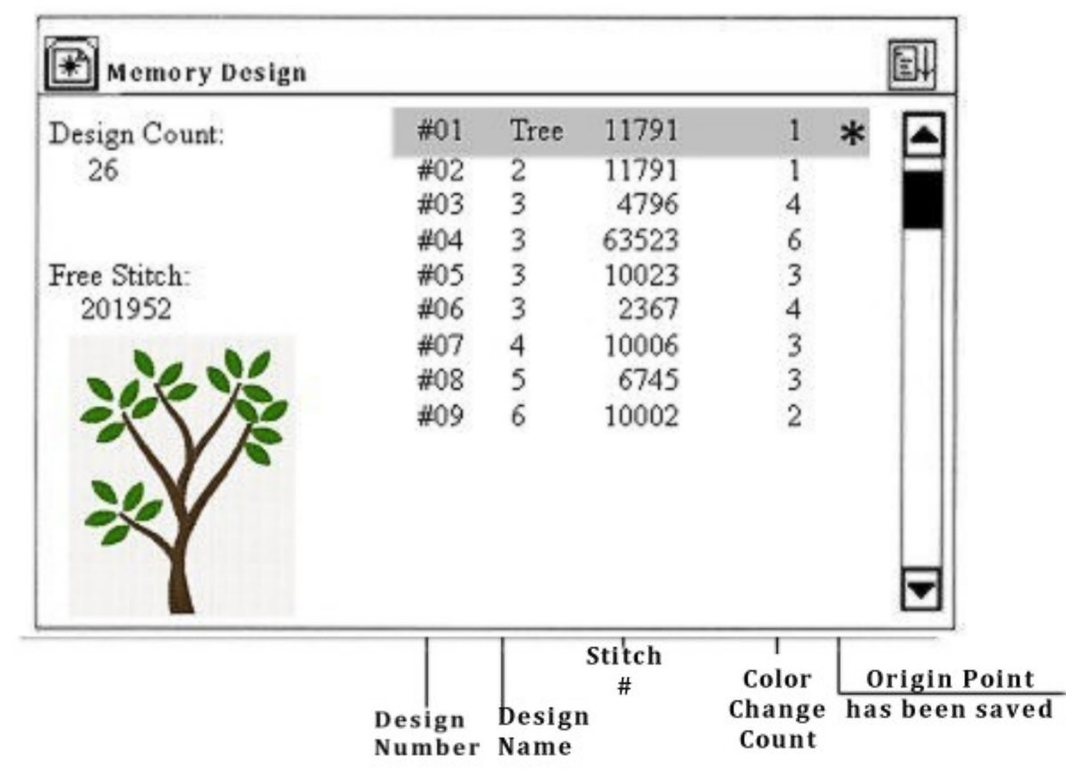
Press to select the design for embroidery. Thearrows are for moving upwards/downwards. The arrows are for turning the pages in the parameter menu. After you press to confirm your selection, the screen will switch to the parameter menu.
If you do not need to change the parameters for this design, press the ESC to exit. Refer to part IV for parameter settings. In the above operation you can press ESC to return to the main screen at any time.

After selecting a new design, press to confirm and the embroidery status on main menu to switch from preparation mode to embroidery confirmation status and then start to embroider.
Parameter Menu
Under embroidery preparation and embroidery confirmation status, you can enter the parameter menu. Some options are unavailable in certain cases. When they are, they will be white.
- All parameters, except the 7th and 8th one on the first page are set and stored with each design separately.

Operation:
Press to enter the parameter setting menu or after you load a design and confirm you can enter the parameter menu when you are in preparation status. The first page of the menu is as follows:
- You can scroll through the two pages of parameters using

The second page of your parameter settings looks like this:
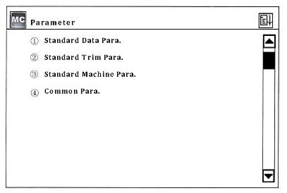
- When a menu option is highlighted, press or use the numerical key pad to select it and press the enter key to enter the sub menu.

Real Time Rotation and Scaling up/down
This parameter is to set image scales, rotation direction and angle for embroidery.

Operation:
- Under the status, press to enter the parameter menu.
Press arrows to move icon to select a parameter and press to confirm the selection. Then you can change the parameter value. Please read the following example.
- Reference the 2nd menu on page 24. From this screen, press to set the scale in the X direction. A cursor “_” appears in the screen, just under the 1.
Example: Set X using numerical keys 1+2+0 = 120% then press.

- Press to set the Y scale.

Example: Set Y using numerical keys 1+6+0 = 160% then press.
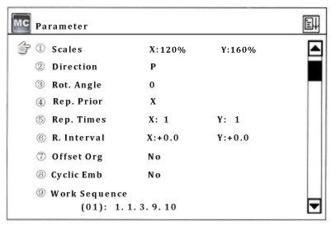

- Press the key to set the design direction. A square cursor appears in the screen highlighting the directional icon P.
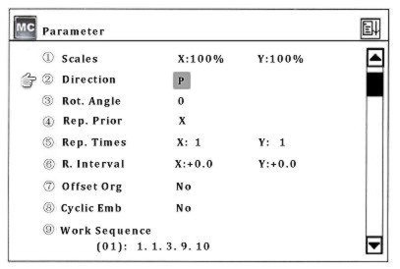
- Press to select one of the eight directions for the design. After making your selections, confirm.
- Press to set the rotation angle which for example appears in the screen like this: O *. Enter the value of the rotation angle between 0-89 by pressing the numerical keys, and then confirm it by pressing.
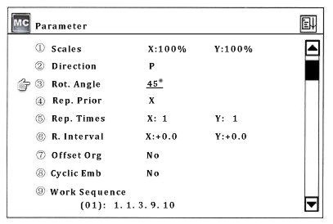

Setting Repetition Embroidery
The machine “Repetition” function is where the machine completes one design and then automatically moves to another position to embroider the last finished design again. (See example parameter below)

Operation:

- In preparation status, enter the parameter menu. Press keys to select the parameter on repetition direction between X and Y and then confirm the selection by pressing.
- Press to set parameter repetition times. Enter the number for X and a number for Y. A cursor will blink under the X or the Y indicating which parameter will be changed.
- Enter the normal repetition times in X direction between 1 and 99. Example: If the value is 3, select the 3 from your numerical key pad and then to confirm the selection.
- Same rule and example applies for the Y direction.
- Press to set the repetition interval. (Point A to point B)
Enter the X-direction interval between the values of -999.9 and +999.9(mm). After confirmation, the system will automatically put a cursor under the Y-direction. The same values apply as in the X direction. When values have been entered, press to confirm.

Offset Point
The offset point is set under the embroidery confirmation status. The offset point can be any point except for the start point. See the following example:
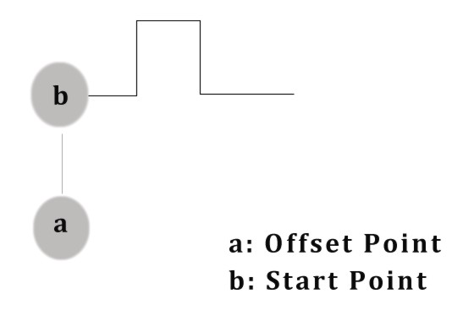
If the offset point has been set, the frame stays at the offset point (a) before embroidery. Press the start button and the frame will move automatically to the start point (b). Press the start button again and the embroidery will begin. Once the embroidery has finished and the machine has stopped, press the start button again and the frame will return to the offset point (a). If the frame has not returned to point (a) the auto point return has been set or not. Press the start button again and the above actions will restart.
- In preparation status, press to enter the first page of the machines parameters.
- Press the or 7 on your numerical key pad for Option #7 and then press to enter the setting of offset point. It is as follows:
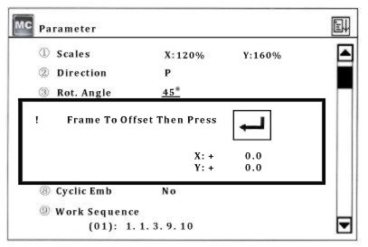

Press to move frame to the offset point and then press to confirm the setting. See example below:
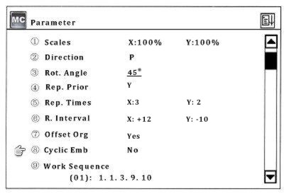

Cyclic Embroidery
Press the key to set the cyclic embroidery (Option #8). When this option is selected, No is now highlighted in grey. Use the arrows to select “Yes” or “No” and then to confirm the selection.

Work Sequence
This is the order in which you want the color choices to sew. This machine reads the colors as color blocks. Based on the design’s color blocks, it can be set according to the color difference or the user’s choice.

The work sequence can only be used in the main screen. Press to activate the work sequence and the icon will show in the main screen.

Operation:
- Press to enter the first page of parameters.
- Or (Option 9) and then to enter the setting of the work sequence. The __ cursor will blink under the number when the user can insert the color choices.
- Enter the numbers, which can not be any larger then 15. To enter numbers larger then 9 press (10+) and number 1 = 11. The same rule applies for 12, 13, 14 and 15.
- After the corresponding stitch position is selected, there will be a under score in the stitch mode indicating that the work sequence is finished. EXAMPLE: (01) 1 . 1 . 3 . 9 . 10
- Then set the second work sequence and press after setting.

- If “Circulate the setting before” is set as “NO”, the following will remain unchanged. If it is set as “YES”, the setting after the cursor will repeat the setting before continuously.

Standard Embroidery Data Parameter
(pg. 2)

This is where the user would set up the data parameters concerning standard embroidery. Their options and default values are shown in the appendix.
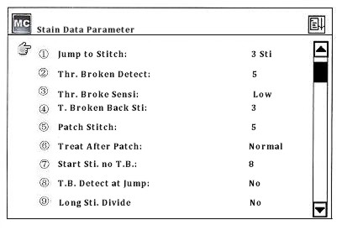
Jump to Trim (Options: No. 1-7)
This function allows the user to decide how to deal with the jump stitch codes in the design. When the parameter is set at “No”, this means there is jumping and without trim. If the continuous jump stitches are less than the set value, there will be jumping and no trim; continuous jump stitches are larger than or the same as the set value, there will be jumping to trim.

- Jumping without trim, the machine will jump stitch based on the jump stitch code within the design.
- If machine is jumping to trim, the machine will act as if over-frame, namely automatic stop, moving frame and automatic start.

Thread Break Detect (Options: No. 3-7)
When this parameter is set as “Yes”, the machine will automatically judge whether there is a thread broken. If this happens, the machine will stop and show the thread break icon.

Use options 3-7 to set the parameters to let the machine know how many stitches it should wait before it starts to test for a thread break.

When the parameter is set at “No”, the machine will not test or know whether there is a thread break.
Thread Break Sensitivity: (Options: Low, High)
Improve the sensitivity of a thread break being detected.

Thread Break Back Stitches: (Options 0-9)
The parameter allows the operator to set the number of stitches the machine should return back once a thread is broken. The machine will automatically stop when a thread break is detected and the value of the parameters is set at “3-7”. If the value is larger then “0”, there will be auto return and the returned stitches are the set value.

Patch Stitch: (Options 0-9)
This parameter tells the machine when the patching status will end. If the parameter value is set at “0”, the patching status will end at the returning point. If the parameter value is larger then “0”, the patching status will end at the value just before the returning point. The value is the number the operator tells the machine to return.

Treat After Patch: (Options: Normal, Reduce, Stop)
This parameter sets the speed after patching. If it is “Normal”, the machine will keep the normal embroidery speed. If it is “Reduce”, the machine will embroider several stitches in lower speed then return to the normal speed. If it is “Stop”, the machine will automatically stop. The machine will continue normal embroidery after it is started manually again.

Start Stitch. No. Thread Break Detect (Options 0-15)
Set this parameter to tell the machine how many stitches after patching it should not check for thread breaks. The options are 0-15 stitches.

Thread Break Detect at Jump: (Options Yes, No)
Set this parameter if you want the machine to check for thread breaks during a jump stitch in the embroidery.

Long Stitch Divide: (Options: No, 7-12)
If a stitch is too long, the main shaft will reduce its rotation speed. The longer the stitch is, the lower the speed will be. The machine can divide the long stitch (longer than the set value) to two or more stitches according to the set value and then jump to finish it.

Jump Length: (Options: 4.5, 6.5, and 8.5)
This is to set the division unit length which is used for dividing the long stitches in embroidery or for dividing the long stitches into jump stitches in design scaling. It is measured in millimeters (mm).

Standard Trim Parameters
(Refer to the Appendix for the standard trim parameter options and default values)

Auto Trim: (Options: Yes, No)
Set this parameter if you want the machine to automatically trim at the end of the embroidery and for operations, like color change and over-frame. Some types of machines are not equipped with the auto trim feature.

Length after Trim: (Options: 1-4)
Set the length of trim with this parameter. The smaller the parameter value is, the shorter the length of the trim.

Action after Trim:
(Options: No Action, Move Needle, Frame to Y and Frame to X)
This action sets the parameter to separate the thread from the mechanical parts, like the thread cutter.

Lock Number after Trim: (Options: 0, 1, and 2)
This tells the machine how many stitches to lock after the trim.

Speed during Trim: (Options: 120)

Slow start after Trim: (Options: 1-9)
Set this parameter to tell the machine how many slow start stitches 1-9 after it trims.

Start Angle of Trim: (Options: 0-10)
This is the mechanism where the operator controls the thread trim and the thread catch. The smaller the number the earlier the thread trims and the thread catches.

Standard Machine Parameters
(Refer to the Appendix for parameter options and defaults.)
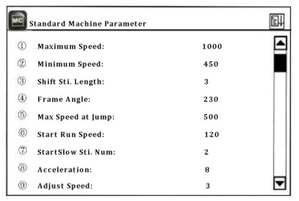
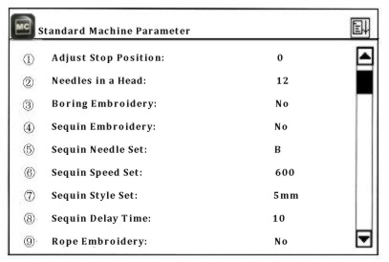
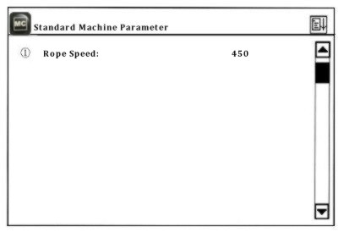

Maximum Speed: (Options: 650, 700, 750, 800, 850, 900, 950 and 1000)
Set maximum rotation speed of the main shaft in embroidery.

Minimum Speed: (Options: 400, 450)
The minimum speed of rotation will automatically be set according to the size of the stitch codes within the design file.

Shift Stitch Length: (Options: 2-7)
This is to set the stitch length in which the speed will decrease from the maximum speed. Its unit of measurements is in millimeters (mm).

When the machine sets the rotation speed automatically according to the stitch length, the maximum speed will be applied for the stitches shorter then the “Shift Stitch Length” setting. The stitches longer than the “Shift Stitch Length” will decrease from the maximum speed for every millimeter of stitch length. When the stitch increases to 12mm, the speed will decrease to the minimum speed.

The three parameter values should be set according to the machine and embroidery in order to prevent the speed being too high and the driving force of the machine being too low.

Frame Angle: (Options: 230, 240, 250, and 260)
The frame angle means that the frame starts to move when the main shaft rotates to a certain angle. Different frame angles will cause different embroidery effects. The user can set these parameters according to different machine, electric parameters and fabric thickness.

Maximum Speed at Jump: (Options: 400, 450, 500, 550, 600, 650, 700, and 750)
This is the maximum setting parameter for the speed during a jump stitch.

Start Run Speed: (Options: 120, 130, 140, and 150)
Set this parameter for the start-up rotation speed of the main shaft.

Start Slow Stitch Number: (Options: 1-5)
This parameter is to set how many slow start-up stitches during the start-up of the rotation speed parameter.

Acceleration: (Options: 1-12)
This parameter sets the acceleration for the speed to rise after the slow start-up stitches. The larger the parameter value is, the faster the machine speed will go from the start-up to the maximum speed.

Adjust Speed: (Options: 1-5)
This parameter is to set the “real speed” closer to the set speed. It is used to compensate for the gap between the “real speed” and the set speed which often happens with season change.

Adjust Stop Position: (Options: 0-20)
This parameter will stop the machine at the 100 degrees stopping point more accurately. The user can increase the parameter value to stop the main shaft at the larger angle and the user can adjust the value between 0-20 by judging whether the shaft exceeds the stop position of 100 degrees.

Needles in a Head: (Options: 3-15)
The value of needles has to be the same as the actual needles on the machine. Your machine is set to default according to the number of actual needles and this parameter should not need to be changed.

Boring Embroidery: (Options: Yes, No)
The user can set the parameter for machines equipped with Boring devices. The parameter should be set as “Yes” if there are Boring devices attached and “No” if not.
Sequin Embroidery: (Options: Yes, No)
The user can set the parameter for machines equipped with Sequin devices. The parameter should be set as “Yes” if there are Sequin devices attached and “No” if not.

Sequin Needle Set: (Options: A, B)
Option A when the Sequin device is located on needle one, and option B when the needle is on the last needle.

Sequin Speed Set: (Options: 400-900)
When “Sequin Embroidery” is set to “Yes”, adjust this parameter to the set speed of the actual embroidery speed. If there is no “Sequin” device, this option will not be available.

Sequin Style Set: (Options: 3mm, 4mm, 5mm, 7mm, and 9mm)
Set this parameter according to the size of the sequin embroidery. For example, if the sequin embroidery is 4mm, the style set should also be 4mm. If the operator makes change in this parameter, the machine must be restarted in order for the changes to take effect.

Sequin Delay Time: (Options: 0-30)
This parameter is to adjust the coordination between the sequin device (rising/descending) time and the sequin embroidery (ending/starting) time which are different due to the difference in their mechanical features. Larger parameter values correspond to longer delay time.

Rope Embroidery: (Options: 1-Needle Number)
Set the needle position with this parameter for rope embroidery. This will enable the rope embroidery in the machine with the rope embroidery device. The setting links to another parameter “Needles in a Head”. If “Needles in a Head” is set as 12, rope embroidery can be set as 1-12. If “Needles in a Head” is set at 9, then the parameter value can only be needles 1-9. “No” means to close the rope embroidery function.

Rope Speed: (Options: 450, 500, 550, 600, 650, and 700)
This is the parameters limit setting for the rotation speed of the main shaft in rope embroidery.

Common Parameters

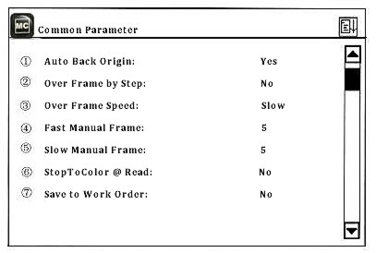

Auto Back Origin: (Options: Yes, No)
When the option is set to “Yes”, at the end of embroidery will be a prompt “Return to start point or offset point, press any key to continue.” If there is no offset point, the machine will return to the start point.

Over Frame by Step: (Options: Yes, No)
This operation is prohibited in embroidery confirmation status.

Over Frame Speed: (Options: Slow, Fast)
The parameter sets the speed of the frame movement as high or low in case of machine over frame.

Fast Manual Frame: (Options: 0-9)
This parameter is for setting the fast manual frame movement.
Low Manual Frame: (Options: 0-9)
This parameter is for setting the slow manual frame movement.

Stop to Color @ Read: (Options: Yes, No)
This parameter transforms the stop codes to the color-change codes when the design is loaded from the floppy disk.

Save to Work Order Sequence: (Options: Yes, No)
When the work order sequence is not effective, the user will manually change color according to the designs. When this parameter is set to “Yes”, the machine will automatically save the color-change sequence as the work sequence, which can be used in the next design.

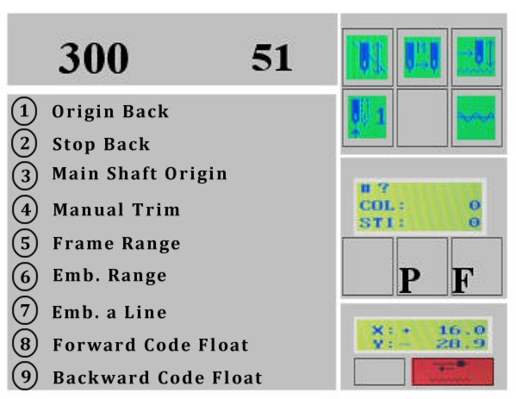
Origin Back
Operation: When the machine stops, select “Origin Back” and to confirm. The machine will automatically return to the start point.

Stop Back
If the frame has been moved or other operations have been performed after the machine has stopped, the user can use “Stop back” to move the frame back to the stop point.

Operation: In confirmation status, enter the manual operation menu, select option # 2 “Stop Back” and to confirm, and then the machine will return to the stop point.

Main Shaft Origin
This operation is to reset the main shaft back to the origin point when the indicator LED is not on, which means (the main shaft has not returned to the origin point) and the machine can not start.

Operation: Enter the operations manual and click on option #3 “Main Shaft Origin” and press the key to confirm. The machine will rotate to stop near 100 degrees, which can also be performed by pressing the shortcut on the panel. Once the light is on, indicating your 100 degrees position, embroidery may begin.

Manual Trim
When “Auto Trim” is set to “No”, the user can manually trim after each color. The manual trim  is located on the control panel as a shortcut.

Frame Range
This is your embroidery design trace. Select this option before you sew out a new design to make sure the design fits inside the hoop. Not all designs are centered in a hoop. Operator should use their best judgment when hooping a design, while at the same time, keeping the distance of the design far enough away from hitting the hoop.

Operation: Press to center the design within the hoop. In preparation mode, operations menu, select option #5 “Frame Range.” You’ll be prompted to “Pull Bar to Start” in other words, press the “Start” button.

*** If design is not within the hoop and the trace is off, move the frame and follow the steps above. ***

Embroidery Range
Operation: In preparation status, select the manual operations to enter the operations menu. Select “Emb. Range” and then press to confirm.

The system will ask the user to input the stitch length for embroidery range. Press the numerical key to enter its range from 10-60 (1=0.1mm).

The system will return to the main screen and at this point will be in “Embroidery Confirmation Status” and the design number in the main screen changes to “101”.

Embroider a Line
This function is available in “Embroidery Confirmation Status” Only.

In the main screen and in embroidery preparation status, press the key to enter the operations menu.

Use arrows to select “Emb. a Line” or from the numerical keys, select option #7 and then press the confirmation key.

The system will ask the user to input the stitch length for embroidering a line. Press the numerical key to enter its range from 10-60 (1=0.1mm).

The system will return to the main screen and at this point will be in “Embroidery Confirmation Status” and the design number in the main screen changes to “102”.

Now the user can embroider the line as the same as its common design. The design number in the main screen will change back to the former one after embroidery.

Forward Code Float
Forward float will move your design to the next stop code in the design quickly making it easy to start the embroidery from any location within the design.

Operation: In the main screen and in embroidery preparation status, press the key to enter the operations menu.

Select option #8 from the key pad or scroll down using your arrows to number 8 and to confirm. The machine will float forward to the next stop or color change code and stop. Repeat these steps to float forward another color.

Backward Code Float
Backward float will move your design to the previous stop code in the design quickly making it easy to start the embroidery from any location within the design.

Operation: In the main screen and in embroidery preparation status, press the key to enter the operations menu.

Select option #9 from the key pad or scroll down using your arrows to number 9 and to confirm. The machine will float backward to the previous stop or color change code and stop. Repeat these steps to float back another color.

Page Two in Manual Operations
Enter the manual operation menu, and turn to the second screen using your, ←/→ arrow key.

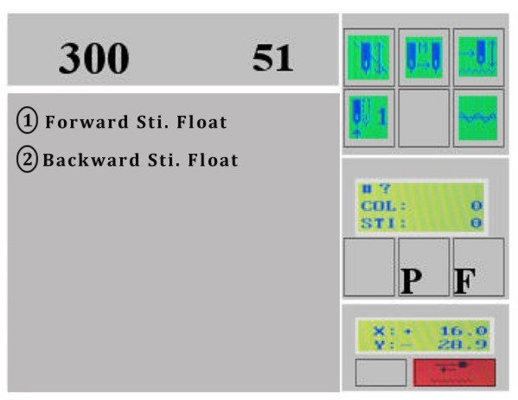
Forward Stitch (Sti.) Float
Operation: Select Option 1, and then to confirm. There will be a prompt asking the user to input the number of stitches to float forward.
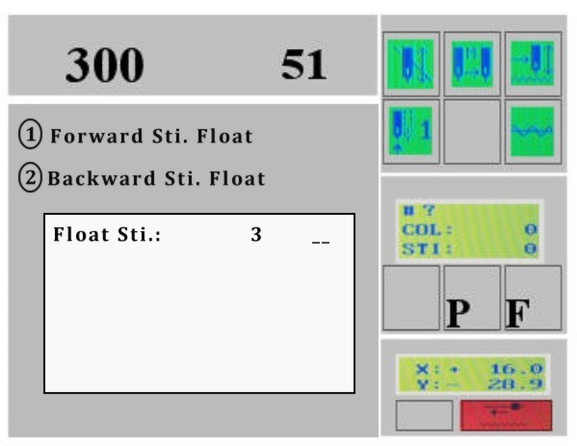
Enter in the number of stitches, and then press the confirmation key. The machine will move forward the number in stitches and in high speed.

Backward Stitch (Sti.) Float
Operation: Select Option 2, and then to confirm. There will be a prompt asking the user to input the number of stitches to float backward.
Enter in the number of stitches, and then press the confirmation key. The machine will move backward the number in stitches and in high speed.
List USB Directory
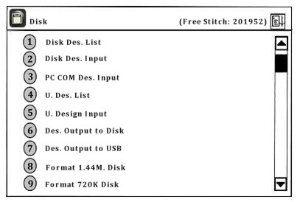
Operation: From the main screen, select the key to enter the menu. There are two options: select option #1 (Disk Des. List) then, for listing the directory from floppy or option #4 (U. Des. List) then, for listing of the design directory from USB.
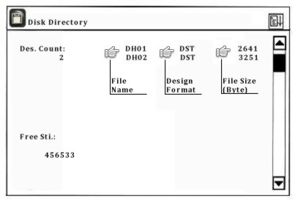
If the design file directory is more than one page, the user can pressto enter the menu of the next page.

Press the key to return to the menu of the upper level. For example: If the user is on page 2, press the once to go back to page 1 or twice to go back to the main menu.

Disk Design Input (Load)
Operation: From the main screen, press the key, to enter the menu for loading a design. Press option “2”for USB Floppy or “5” for USB, and the key to confirm. Once the design directory is displayed, the user can scroll to select a design, then the key to confirm the selection.

Then the system will provide and display an available design number, which the user can change. For example: the number in this example is 20, but the user wants to use 65, press the “6” and “5” then to confirm. Otherwise, continue to the following operations.
Disk Name: DH01
Memory No: 20
Memory Name:
A B C D E F G H I
J K L M N O P Q R
S T U V W X Y Z 0
1 2 3 4 5 6 7 8 9
The user will be prompted to give the design a name. If the user uses the disk name as the memory name, press and continue. To change the name, use to select the character and  to confirm the letter. [CL] will clear the choice, will confirm the choice.

Immediately after entering the design name and confirmation of the changes, a progress bar is displayed [Emb. New Design: NO]. If the machine is in preparation status, it will enter the parameter menu. If the machine is embroidery status, the machine will ask whether to embroider the design now.

Press to select [Yes] and to confirm and the user will be taken to the parameter setting operations.

PC COM Design Input:
This machine does not have this feature.

Delete Designs on USB or Floppy Disk
(The operations for USB and USB Floppy Disk are similar. The following are the operation for USB)
Operation: From the main screen and in preparation status, press the key. Press to enter the next page and to choose “Delete U. Design”. The machine will read the directory and display its contents. Using the arrows, select the design. Press to confirm the choice and delete the design or press to exit and return to the main screen.

Des. Output to Floppy/USB Disk
This option is to save the memory designs to disk. Note: This machine only has the capability to save in a “DSB” and software will not be able to read the file; however, another machine will read it fine.

Operation for Des. Output to Disk: Press the key, and then select option # 6 from the menu, to confirm. The system will ask to input (enter) a memory number for the design being transferred from machine to disk.

Operation for Des. Output to USB: Press the key, and then select option # 7 from the menu, to confirm. Use the key pad to enter the design number or press to enter the memory design directory to select the design using the, then refer back to Part III.

Press the key. The confirmation will fail if the design number is not within the directory. When the design number is correct, the system will display its memory name and ask to enter a disk name.

If the user wants to use the memory name as the disk name, press the key. Otherwise, use and to select the characters. When the name has been entered, select the key to confirm the name given. The transfer begins and a progress bar appears in the process. The system will return to the main screen once the transfer has completed.

To cancel and return to the main menu, press the [CL] button.

Format Disk
Caution: This process will remove all designs from memory. Be sure these designs are somewhere else before moving forward with the format. (Computer, Floppy, Backup, etc)

This machine will format a 1.44/720K floppy disk and USB drive in DOS format. A new disk has to be formatted before use.

Operation: In the main screen and in preparation status, press the key. Press option # 8 to select “format 1.44 Disk” or option # 9 to select “Format 720K disk”.

In the main screen, select key and use to go to page 2 for this menu. Option # 1 is “Format U. Disk” which is USB. Press to confirm the formatting operation. A progress bar will appear and once the system has completed the format it will return to the main screen.

Note: This particular machine supports the USB floppy and USB drive. Communication from Computer to Machine is not available.
Enter the Memory Design Operation Menu
The user can enter the memory design operation under both embroidery and preparation status. There are a few options that are displayed but will be unavailable to the operation. When they are unavailable, the will be White in color.

Operation: In the main screen, press key to enter the design operation menu.
Page One
Press to switch between the pages.
Page Two
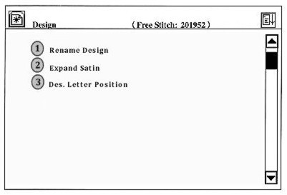
Press to make a selection or numerical pad to enter the number, and then to confirm and enter the submenu under the selection.

Select Design for Embroidery
Operation: In the main screen and in preparation status, press key to enter the design operation menu, and then, to enter the first menu option. If the design’s memory number is known, enter this when prompted using the numerical key pad then to confirm.

For example: If the design number is 15, press the “1” and the “5” then to confirm.

When the number does not exist in the memory, the selection will fail and the user can press [CL] to clear the data and select another design number “or” twice to go straight to the directory listing.

Press to select the design intended for embroidery, and then confirm the selection. The screen will turn to the parameter settings menu.

Please refer to the parameter section (Part IV) in this manual for details on the settings.

If the user does not need to change the parameters, press key to exit to return to the main screen at any time.
Show Memory Design
“List designs and show their parameters”
Operation: From the main screen, press key to enter the design operation menu. Go to Option # 2 and confirm selection.

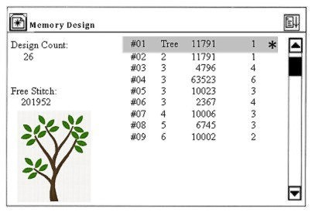
Use the arrows to select the design and then confirm the selection. The machine will then display this screen.

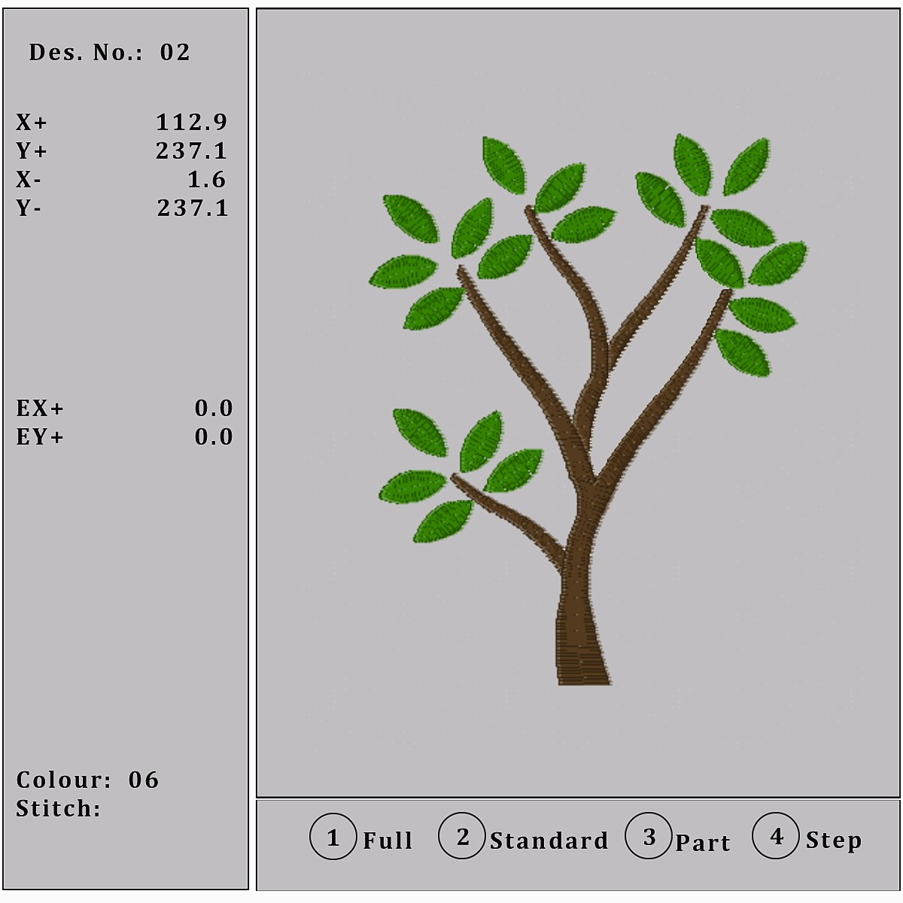
The design’s basic information is located on the left hand side including the design color, coordinates of boundary lines, coordinates of the stop point, number of design color and stitches. The design can also be displayed in different ways to show details more clearly.
Disk Input
Press from the main menu to enter the design operations menu. Then select option # 3 “Disk Input” and confirm.

The floppy light is on when the machine is reading from the device. Use the arrows to select the design and then to confirm the selection.

The system will provide and display an available design number which can be changed by the user. To enter a new number, press the [CL] first to clear out the number provided by the system.

Now that the design has a number, the system prompts for a name to store into memory. If the user chooses to use the disk name press the. To change the memory name, use to select the characters and to confirm the character.

A progress bar is displayed for the process. Immediately after, if the system is in embroidery preparation status, it will enter the parameter settings screen. If the system is in embroidery confirmation status, the user will be asked if they want to embroider the design now.

To embroider the new design, use the to select “Yes” and then to confirm the selection. The system will enter the parameters setting operation. (Refer to Part IV for parameter settings.) To embroider the original design to choose “No” and then to confirm. The system will then return to the main screen.

Delete Memory Design
Operation: In the main screen and in the preparation status, press to enter the design operation menu. Press, and the following screen will appear.
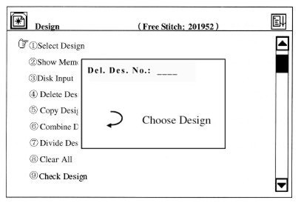
Enter the number, or press the key again to enter the directory. Then use to select the design being deleted and then to confirm operation.

Copy Design
This operation is to copy a memory design and save it as a new design in the memory.
Operation: Under the main menu, press to enter the memory design operation menu.

Press option # 6 (Copy Design) and then press to confirm operation. The system will ask for the memory number of the design to copy. Using the numerical key pad, enter the number of the design or press to enter the directory.
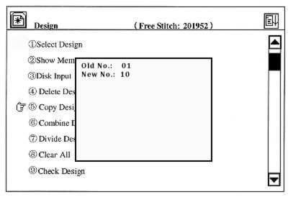
Please note: If the number of the design is not in memory, the confirmation will fail.
The user can enter a new number using the numerical key pad and then. (If the number has been used by another design, the confirmation will fail.) With the new design number and name confirmed, the machine begins to copy the design. When the process is complete, the system will return to the main screen.

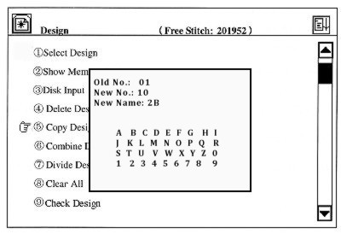
NOTE: will take the user out of the operation process and return to the main screen.

Memory Design Operations that will NOT be listed in this manual are: Combine a Design, Divide a Design and Design letter pattern. Please refer to your software for these types of design edits.

Clear All
This will delete ALL the designs in the memory. Please handle with caution and make sure you have a back up of these designs on a computer or backup source.

Operation: Under the main screen and in preparation status, press to enter the design operation menu. Use thearrows to select the option “Clear All” and then. The system will ask the user to confirm the operation
. 

Press to confirm “Yes” and the system will clear all the designs in memory and return to the design editing menu. To exit, arrow up/down to select “No” and to exit.

Check Design
For an area in the design that is causing thread breaks or if there is another issue within the design, the user can use this operation to check the design.

Operation: Under the main screen, press to enter the memory design operation menu. Then use to turn to the second page.

The cursor is before the option “Check Design”, press and the system will prompt for the user to enter the design number.

Enter the number for the design or select one from the design directory. The system will check the selected design. If the system finds the design is correct, the screen will display “Design Right” and if the design is wrong, the screen will display “Design Wrong”.

Rename a File
On the second screen in the design operations menu, there is an option to change the name of a file. Follow the prompts to select the design and the following screens will appear.
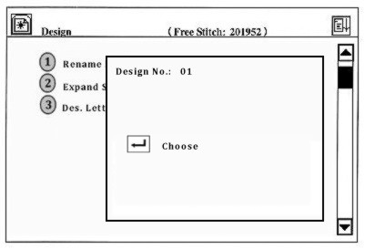
Enter a new design/file name for the selected design
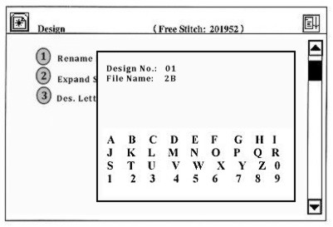
Press the confirmation key to confirm the data and the system will complete the change. Once confirmed, the system will return to the design operation menu.

Expand Satin
On the second page of design operation menu, there is an option for expanding the satin to create a new design.

This function was designed to compensate for the satin stitch difference caused by the mechanical difference of the machine. Use it to widen or narrow the satin stitch to the desired width.
Soft Set Limit
Operation: From the main screen and in preparation status, press the key to enter the Assistant menu.
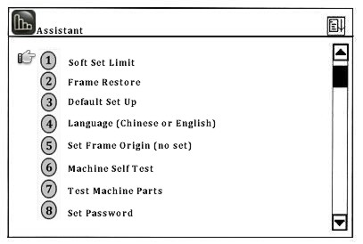
Use to select “Soft Set Limit” or press 1 and to confirm. The following screen will be displayed.
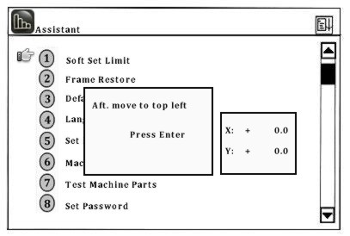
Press the frame-moving keys to move the frame to the point destination and then to set as the top left point.

Using the frame-moving keys again, set the bottom right point. Once both are set, the “Soft Limit” is now active. See below for “Bottom Right Point” example.
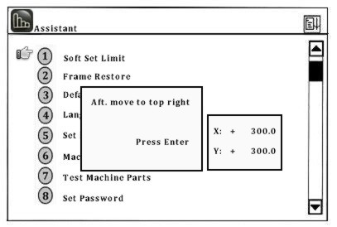
Frame Restore
Accidental power-off may take place during embroidery. When the power is back on, embroidery can continue “if” the frame has not moved away. If the frame has been moved away and the “Origin point” has been set, the user can use “Frame Restore” to restore the frame back to the position where the frame was when the point was turned off. If the origin point has not been set, the option “Frame Restore” will not be available.

NOTE: Before you can set “Frame Restore” the “Origin Point” has to be set first. Frame Restore is NOT an option for hats.

Operation: From the main menu, select the “Assistance Function” key. Then select option # 2 for “Frame Restore” by using the arrows or pressing the number 2. Press and the frame will move to the origin point first, then to the point where the machine was powered off.

See page 62 for the operation for setting the “Origin” point.

Default Setup
“Parameter or Variable Values”
Below are some default settings in this machine.

Current Stitch: 0
Stitches Count: 0
Current Rotation Speed: 1000
Frame Displacement (Display): X: 0.0 Y: 0.0
Embroidery Mode: Normal Embroidery
Manual Frame-Moving Speed: Low Speed

Operation: From the main menu and in preparation status, press the function key to enter the assistant menu. Use the arrows or numerical keys to select the option “Default Setup”.

Press to restore the default setup and then return to the assistant menu. Otherwise, press to exit.

Switch to English
Operation: From the main menu and in preparation status, press the function key to enter the assistant menu. Use the arrows, or press option # 4 to change the language from Chinese to English or English to Chinese and then to confirm.

Set Frame Origin
By setting the frame origin point, you can restore the frame in case of an accidental power-off in the middle of embroidery.

Operation: From the main menu and in preparation status, press the function key to enter the assistant menu. Use the arrows, or press option # 5 for “Set Frame Origin” and the following screen will be displayed.
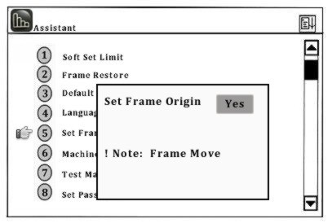
Use the arrows to choose “Yes” or “No” and then to confirm. The frame will move to the origin point and then back again. Back in the assistant menu, this option now displays “have set” and “Frame Restore” is now available.

Machine Self-Test and Test Machine Parts
These functions are provided for machine maintenance. “Machine Self Test” is to check the computer control circuits and “Test Machine Parts” is to check the mechanical parts.

Note: For assistance with these maintenance functions, we recommend calling in for support.
Set Password
Setting a password can protect the machine from undesired results from accidental parameter changes. Once the password is set, the user has to enter the password before changing any parameter values.

Parameter | Choice | Standard Value
X Scale (%) | 50-200 | 100
Y Scale (%) | 50-200 | 100
Design Direction |  | P
Rotation Angle | 0-89 | 0
Real Time Scale Parameters

Repetition Parameters
Parameter | Choice | Standard Value
Repetition Prior | X,Y | X
Repetition Times (X) | 1-99 | 1
Repetition Times (Y) | 1-99 | 1
Repetition Interval (X) | -999.9 / +999.9 | 0
Repetition Interval (Y) | -999.9 / +999.9 | 2

Switch Parameters
Parameter | Choice | Standard Value
Thread Break Detect | Yes/No | Yes
Auto Back Origin | Yes/No | Yes
Start Slow Aft. Trim | 1,2,3,4,5,6,7,8 | 3
Adjust Stop Position | 0,1,2,3,4,5,6 | 3

Malfunction Table
CODE | CAUSE/REASON
E--01 | Disk Failure  In case of a “Disk Failure” you can format the disk in your PC and check whether there is a bad section in the disk.
E--02 | Wrong Disk Format  If the embroidery machine is unable to recognize the storage format, the user can format the disk in the embroidery machine’s computer system.
E--03 | No Disk  Check the floppy drive and make sure there is a floppy disk in the machine.
E--04 | Write Protect  It shows that there is a write protect for the working floppy or USB disk so that data can not be modified or entered. Please ensure that the write protect is in the opening mode.
E--05 | No Free Disk Space in Directory  There are no more directories left on the floppy or USB.
E--06 | No Free Disk Space  The disk or USB has reached its storage limit. The user can clear some storage space by removing files from the disk or USB.
E--07 | Format Fail  The machine is unable to format the disk/USB. Please check this device and make sure write protect is open or the disk has not suffered unrecoverable damages.
E--08 | No Design End Code  There is no end code in the design. Please check the design in your software.
E--10 | Emergency Stop - Reset Button  Press the stop button in the case of an emergency. To resume, the user will need to turn the button according to the direction printed on the upper bottom of the button.
E--11 | Startup without Embroidery Confirmation  The embroidery confirmation has not been done. After a design file is selected, the user will have to press the confirmation key before embroidery will start.
E--12 | Returned to Origin Point Already  In manual or automatic returning (tracing back), the machine has reached the origin point of the design.
E--13 | No Exit, Embroidery Confirmation  It appears when the user operates without exiting the embroidery confirmation status. Press the confirmation key to exit.
E--14 | Memory Parameter Lost  The parameters stored in memory are lost. Please check whether the battery voltage of the main board is under DC2V. If so, please change the batteries.
E--15 | Memory Design Lost  The designs stored in memory are lost. Please check whether the battery voltage of the main board is under DC2V. If so, please change the batteries.
E--16 | No Design in Memory  There are no designs in memory. Please load designs from the floppy or USB into the machine.
E--17 | No Free Design Number  The system can store 99 into its memory and will not hold more even if there is free space left.
E--18 | Memory Design Number does not Exist  The selected design number does not exist in the memory.
E--19 | Not Enough Memory Space  Because of occupation by memory designs, the memory can not provide enough space for design input or design review.
E--50 | Encoder Abnormal  Results in in-correct embroidery. Check the cable connection of the encoder socket in the main shaft control board. If the connection is right, check to see if the encoder is damaged.
E--51 | Stop Position not at 100 degrees  The main shaft has not stopped at 100 degrees. The user can adjust the parameter “Adjust Stop Pos.” to solve the problem. If parameter adjustment fails, check whether it is caused by mechanical problems such as separation between motor shaft and the mechanical shaft of the main shaft.

E--53 | Stepping Motor is Abnormal  The malfunctions with the stepping motor have resulted in overflow or over-temperature. Check the connection of the X/Y axis motor and the stepping driver. You can turn on the power to recover.
E--54 | Color Change Exceeds Limit  The wrong returning signal from the rheostat causes that the rotation of the color change motor exceeds the limits. Check whether the installation of the rheostat is correct and whether the rheostat is damaged.
E--55 | Color Change Exceeds - 2 sec.  Overtime of color change means that the color change motor has not changed colors to the designated time. The cause may be the motor stopping rotation caused by the wrong mechanical installation, or the connection problem of the color change motor plug, or the damaged motor.
E--56 | Color Change Half Return Abnormal  When the color change is in the correct needle position, the icon 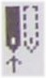 appears. The corresponding needle number is shown on the right of the icon. “Color change half return abnormal” means that both needle symbols of the icon are dotted lines (one should be in real lines). The user can manually turn the color change wheel to get it in the right position. If such problems appear frequently, please check the rheostat and the mechanical installation.
E--57 | Needle Position Abnormal  The needle position in the color change shows as “?”. The user can manually turn the color change wheel to get it in the right position. If such problems appear frequently, please check the rheostat and the mechanical installation.
E--58 | Main Motor Exceeds - 2 sec.  When the main shaft is started, the main shaft motor does not move or the main shaft is in uncontrolled rotation. Check the system’s power supply and make sure its ok. Also check the connection of the main shaft motor and whether the motor is damaged, or if there is an overflow or damage on the main shaft control board, and whether the zero position optical coupler is damaged.

E--59 | Color Change Motor Reverse  It’s the motor reverse rotation caused by reverse connection of the motor wire winding.
E--61 | Frame Software Limit  When the function “soft limit” is selected, this error will appear after the frame goes beyond the set limit in the process of manually moving the frame or embroidery. To solve this problem, check before embroidery whether the set embroidery limit fits the need of the design.
E--63 | No Frame Moving Angle  May be caused by:  - Damaged zero position optical coupler  - Damaged motor encoder  - Separation between the motor axis and mechanical axis of the main shaft, or…  - The machine is not grounded
E--70 | No Zero Point Signal  May be caused by:  - Damaged zero position optical coupler  - Damaged motor encoder  - Separation between the motor axis and mechanical axis of the main shaft, or…  - The machine is not grounded
E--74 | Cutter Not in the Right Position  The cutter has not returned to the starting position. It may be a mechanical problem or the proximity switch for checking at the starting point has been damaged.
E--75 | Trimming Motor Overtime  May be caused by:  - Damaged cutter motor  - Damaged proximity switch (cutter starting point)  - Wrong Connection between the plug and socket of the cutters motor in the main shaft control board, or…  - The power supply
E--80 | Overcurrent/Restart  The main shaft stops running because the main shaft motor is damaged or there are other mechanical problems.
E--89 | Lost a Pulse  This is caused by a damaged encoder or bad connection of the plugs and the sockets of the encoder or the machine is not grounded.
E--110 | Error at Save Secret  Storage error caused by a wrong operation on the passwords.
E--130 | No Respond  Something is wrong with the MASTER module so it is unable to carry out the orders from the computer.
E--131 | RSP. Disagree Command  The MASTER module has not been installed; there is a bad connection of the MASTER module or the breakdown of the MASTER module.
E--150 | No Device  May be caused by:  - The USB has not been connected  - There is a bad connection with the USB, or…  - The USB is damaged
E--151 | Device Full  The USB disk is full or there is not enough space to load the design.
E--152 | Device Error  May be caused by:  - Malfunction of the USB disk  - E1904A is not installed, or…  - E1904A has a bad connection
E--153 | File Exist  The created file name is the same to an existing file name on the USB disk.
E--154 | File Not Found  The file does not exist on the USB.
E--157 | File Not Open  The file has not been open.

E--158 | State Error  Something is wrong in the process of reading the sections of the USB disk.
E--159 | System Error  Something is wrong in file system.

Supported File and Disk Forms

Barudan (Specified Data) | DSB
Barudan (Wilcom) | T03
Barudan | U??
Bits & Volts | BRO
Compucon | XXX
Datastitch | STX
Gunold | STC
Melco | EXP
Pfaff | KSM
Pfaff (Wilcom) | T09
Proel | PMU
Proel (DOS) | PUM
Tajima | DST
Tajima (Wilcom) | T01
Toyota | 100
ZSK | DSZ
ZSK (Wilcom) | T05

Malfunction Tackling
- Communication Time Out: After the embroidery machine enters the state of getting ready to receive data, the machine will automatically exit “receiving state” if there is no data being entered for 36 seconds. To Exit.
- Abnormal communication breaking: After the embroidery machine begins to receive data, you can press the on the embroidery machine twice to exit when the computer system crashes or in other situations the user feels it is necessary to stop receiving data.

